CDAC Mumbai

DAC Forum & Mentor

Assessment



**SOFTWARE REQUIREMENT SPECIFICATION**

**FOR**

**DAC FORUM AND MENTOR ASSESSMENT**

**[16-06-2017]**

**CDAC, MUMBAI**

**Revision History:**

|  |  |  |  |  |
| --- | --- | --- | --- | --- |
| **Version.** | **DATE** | **Authored** | **Reviewed** | **REASON FOR CHANGE** |
|  |  | **By** | **By** |  |
| 00 | 16/06/2017 | Team-11 |  | 1st release |
|  |  | (Ocean’s |  |  |
|  |  | Eleven) |  |  |
|  |  |  |  |  |

***i***

CDAC Mumbai

DAC Forum & Mentor

Assessment

**Table of Contents**

|  |  |  |
| --- | --- | --- |
| **1. Introduction .....................................................................................................................................** | | **1** |
| 1.1 | Purpose .................................................................................................................................... | 1 |
| 1.2 | Document Conventions ............................................................................................................ | 1 |
| 1.3 | Intended Audience and Reading Suggestions .......................................................................... | 1 |
| 1.4 | Product Scope ........................................................................................................................... | 2 |
| 1.5 | References ................................................................................................................................ | 3 |

|  |  |  |
| --- | --- | --- |
| **2. Overall Description .........................................................................................................................** | | **3** |
| 2.1 | Product Perspective .................................................................................................................. | 3 |
| 2.2 | Product Functions ..................................................................................................................... | 3 |
| 2.3 | User Classes and Characteristics .............................................................................................. | 3 |
| 2.4 | Operating Environment ............................................................................................................ | 3 |
| 2.5 | Design and Implementation Constraints .................................................................................. | 3 |
| 2.6 | User Documentation ................................................................................................................. | 4 |
| 2.7 | Assumptions and Dependencies ............................................................................................... | 4 |

|  |  |  |
| --- | --- | --- |
| **3. External Interface Requirements** | | **..................................................................................................4** |
| 3.1 | User Interfaces .......................................................................................................................... | 4 |
| 3.2 | Hardware Interfaces ................................................................................................................. | 5 |
| 3.3 | Software Interfaces ................................................................................................................... | 5 |
| 3.4 | Communications Interfaces ...................................................................................................... | 5 |

|  |  |  |  |
| --- | --- | --- | --- |
| **4.** | **System Features ..............................................................................................................................** | | **5** |
|  | 4.1 | System Feature 1 ...................................................................................................................... | 5 |
|  | 4.2 | System Feature 2 (and so on) ................................................................................................... | 5 |
| **5.** | **Other Non-functional Requirements.............................................................................................** | | **6** |
|  | 5.1 | Performance Requirements ...................................................................................................... | 6 |
|  | 5.2 | Safety Requirements ................................................................................................................. | 7 |
|  | 5.3 | Security Requirements ............................................................................................................. | 7 |
|  | 5.4 Software Quality Attributes ....................................................................................................... | | 7 |
|  | 5.5 | Business Rules .......................................................................................................................... | 7 |
| **6.** | **Other Requirements .......................................................................................................................** | | **8** |

***ii***

CDAC Mumbai

DAC Forum & Mentor

Assessment

**1. Introduction**

**1.1 Purpose**

**DAC Forum and mentor assessment** is a web application which provides an interface throughwhich administrative entities can view the mentors performance. The proposed system eliminates the manual entry of attendance mentors, to and fro talks between administrators about how students are coping and instead automates it. It also provides an interface through which student can ask questions which can be answered by mentors and other students.

**1.2 Document Convention**

**Headings: -**

Text: -Bold

Font-Size: - 14

Highlighting: - Times New Roman

**Sub Headings: -**

Text: -Bold

Font-Size: - 12

Highlighting: - Times New Roman

**Header: -**

Text: - Simple

Font-Size: -10

Highlighting: - Times New Roman

**Footer: -**

Text: - Simple

Font-Size: -10

Highlighting: - Times New Roman

**Intended Audience and Reading Suggestions**

This document is intended for developers, users, testers and project managers for the purpose of understanding the design of system in terms of different perspectives. Further, this document contains functionalities and characteristics of system along with the working

***1***

CDAC Mumbai

DAC Forum & Mentor

Assessment

environment. It also includes other information related to system such as external interface requirements, features and other non - functional requirements.

**1.2 Product Scope**

Our project is targeted to reduce the cumbersome process of maintaining a physical register for attendance of mentors and help students to get guidance from mentors on the go. The Admin can view Mentors performance in graphical format and also this application will help students to ask questions and get answers even if mentors are not present themselves.

**1.3 References**

<https://angular.io/>

<https://material.angularjs.org/latest/>

<https://stackoverflow.com/>

<https://expressjs.com/>

<https://nodejs.org/en/>

**2. Overall Description**

**2.1 Product Perspective**

Generally in hotels waiter comes and collects the order on either notepad or tab. So they are not able to maintain their customer’s records and feedback about their food. Even the customer cannot track his/her order.

So this application will provide them all this facility. Customers can track his/her order and after ordering food in the meantime they can play a game, listen to music, etc. Also, a hotel owner can maintain a database of his customers and collect feedback from them. Then for payment, this application has two options – either customer can pay by cash or if the customer wants to pay through online then they can pay through the default payment gateway.

**2.2 Product Functions**

* The admin will be able to view customers records.
* The customer will be able to track his/her order.
* After ordering food in meantime they can play a game, listen to music.

***2***

CDAC Mumbai

DAC Forum & Mentor

Assessment

**2.3 User Classes and Characteristics**

**Admin**:

This person will be able to access all the functions of the system. This person can view Customers record, can add chef and tables of the student also can view

**Customer**:

Customer can view menu list, his order and time which is required for order delivery Customers will be able to give feedback for menus.

**Chef**:

This person can accept the order.

**2.4 Operating Environment**

* **Hardware platform:**
  1. Processor – Above Pentium 4, with clock speed of 2.0 GHz
  2. RAM – 1 GB or above
  3. Hard Disk – Free disk space of above 1 GB
* **Software platform:**
  1. Front-end: HTML, CSS, Bootstrap.
  2. Back-end: MySQL , Spring.
* **Supported tools:**
  1. Visual Code Studio, MySQL Workbench

**2.5 Design and Implementation Constraints**

**Constraints:**

1. The user interface is only in English. No other language option is available.

o The chef can log-in only with his assigned user-name and password.

o Limited to HTTP/HTTPS

***3***

CDAC Mumbai

DAC Forum & Mentor

Assessment

**2.6 User Documentation**

User documentation mainly comprises of Help menu of application. It will give all the minute details about the project, if any user has any query about any module or functionality, one can refer it and see how to operate the application. This report is the complete documentation of our project. It gives complete details about the project, its functionality, users, software used, hardware requirement,environment and so on.

**2.7Assumptions and Dependencies**

* + Assumptions:
    - There is an active internet connection with the system.
    - The system has an internet browser installed
    - Users know the English language, as the user interface will be provided in English.
  + Dependencies:
    - There is a need for constant updating of records after each order.
    - Active participation from Chef for accepting the records.

1. **External Interface Requirements**

**3.1 User Interfaces**

The main element is web-pages using HTML, Angular Material. Multiple interfaces are

there like log-in pages, home pages of Student, Admin, Mentor, and also the Forum.Admin will

update excel sheet for marks and accordingly data will be persisted. Based on these marks and

the feedback provided by students, mentors performance would be evaluated in a graphical

format.

***4***

CDAC Mumbai

DAC Forum & Mentor

Assessment

**3.2 Hardware Interfaces**

In the hardware interface, the system interacts with hardware given the processor is above P4 with clock speed of 2.0 GHz with 1 GB RAM and the Hard Disk with 1 GB free space in the memory. In future enhancements, it can be made responsive to be able to work with mobile devices as well.

**3.3 Software Interfaces**

In software interfaces, Node JS is the back-end technology used along with MySQL Database. The front-end technologies include HTML, CSS, Bootstrap, Angular and Angular Material. Data will be communicated between these interfaces accordingly.

**3.4 Communications Interfaces**

The main communication interface for interacting with the System will be the web Browser.

**4. System Features**

**4.1 Description**

This system will help CDAC students to ask questions and get their doubts solved. This system will help students to see their performance. This system will help CDAC Management automate the mentor attendance system. This software also aims at carrying out an analysis of the mentor’s performance which will in return help us improve the performance of the students. This system will help us generate a performance result of the student and the mentor as well.

**4.2 Functional Requirements**

**4.2.1 Forum**

1. The system will allow students to ask questions and put forth their doubts. o The system will allow others to answer the questions.

o The system will show who has posted the question and who has answered the question.

***5***

CDAC Mumbai

DAC Forum & Mentor

Assessment

**4.2.2 Agenda**

1. The mentor will be able to post the agenda for the entire session that he/she wishes to take.
2. The system shall allow students to suggest and add up some points in the suggested agenda.
3. The system shall also display the ongoing/ important agenda on the page (display).

**4.2.3 Mentor Attendance**

1. The system should maintain a log of the mentor’s attendance.
2. The system will thus help us automate the process of manual attendance. o Thus, using this system, we will be able to save a lot of time and energy.

**4.2.4 Student Rank**

1. The system shall display the student rank based on their performance.

**4.2.5 Mentor Analysis**

The system shall allow the CDAC Management to view the performance of the mentor based on various parameters. This will help the CDAC Management understand how the students have improved as well.

1. **Performance Requirements**

The system should store all the database records of each student, mentor and admin staff properly and the application should be available for use 24*7 through the server. Also, the application should be user friendly with a proper user interface which makes it easy for the user to understand. All the options should be present in properly accessible places for user convenience.

**5.1Safety Requirements**

All login ids and passwords of the students, mentors and especially admin staff should be protected for privacy using whatever constraints required in the database or the application. In case any admin staff access account is hacked by any intruder, user id and passwords of all the

***6***

CDAC Mumbai

DAC Forum & Mentor

Assessment

admin staff personnel should be changed and new passwords should be issued to all students. Student and Mentor records are to be backed up securely across database servers. Incase database is hacked by someone and data is deleted a backup server should be present for such purpose.

**5.2Security Requirements**

All passwords of the administrators should be protected for privacy using whatever constraints required in the database or the application. Transactions regarding student and mentor records should be carried out properly. Only admin staff will have access rights to the student data according to the need for E.g.: -marks and feedback for mentor, passwords etc. The database should be protected from attacks and unauthorized access. The interface should be protected from attacks. All passwords should be stored as a secure hash of the administrator password.

5.3**Software Quality Attributes**

**5.3.1Availability**

The system should run on a variety of operating systems that support the JavaScript language. The system should run on a variety of hardware.

**5.3.2 Accessibility**

The software will be accessible to admin, students and mentors.

**5.3.3 Compatibility**

The software will be compatible with multiple platforms.

**5.3.4 Durability**

The software will be tested for working with multiple users.

**5.3.5 Effectiveness**

The software will be made to handle operations effectively.

**5.3.6 Maintainability**

The system should be easy to maintain. There should be a clear separation between the interface and the business logic code. There should be a clear separation between the data access objects that map the database and the business logic code.

***7***

CDAC Mumbai

DAC Forum & Mentor

Assessment

**6.Other Requirements**

* **Appendix A: Glossary**

1. **SRS:** Software Requirement Specificationo **GUI:** Graphical User Interface

o **P4:** Pentium 4

o **SQL:** Structured Query Language

o **HTML:** Hyper Text Markup Language

o **CSS:** Cascading Style Sheet

***8***

CDAC Mumbai

DAC Forum & Mentor

Assessment

**Appendix B: Analysis Models**

1. **Use Case Diagram**

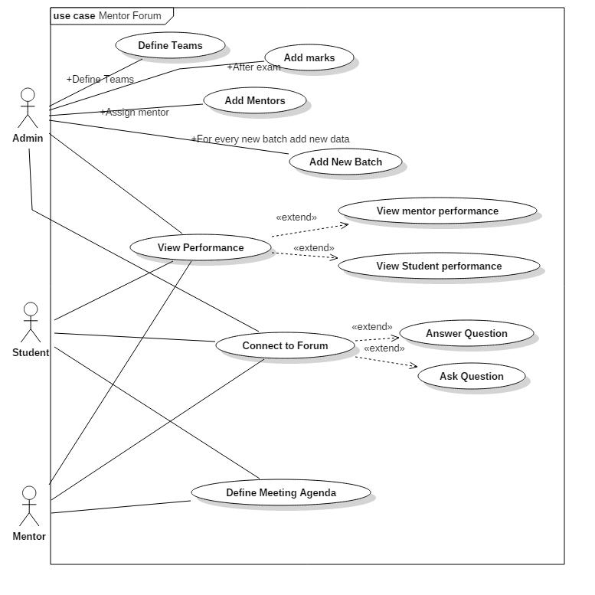

***9***

CDAC Mumbai

DAC Forum & Mentor

Assessment

1. **Class Diagram**

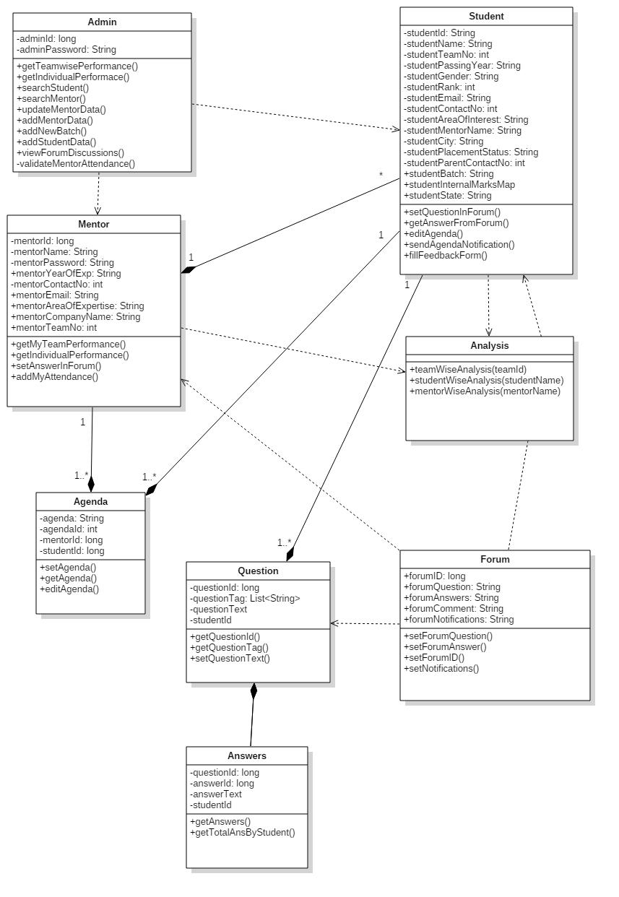

***10***

CDAC Mumbai

DAC Forum & Mentor

Assessment

1. **Activity Diagram 1.1:**

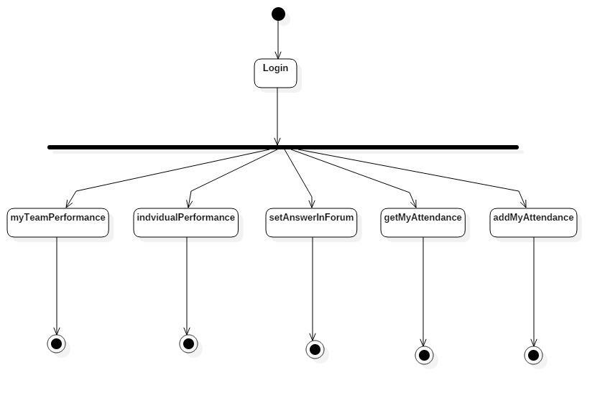

***11***

CDAC Mumbai

DAC Forum & Mentor

Assessment

**Activity Diagram 1.2:**

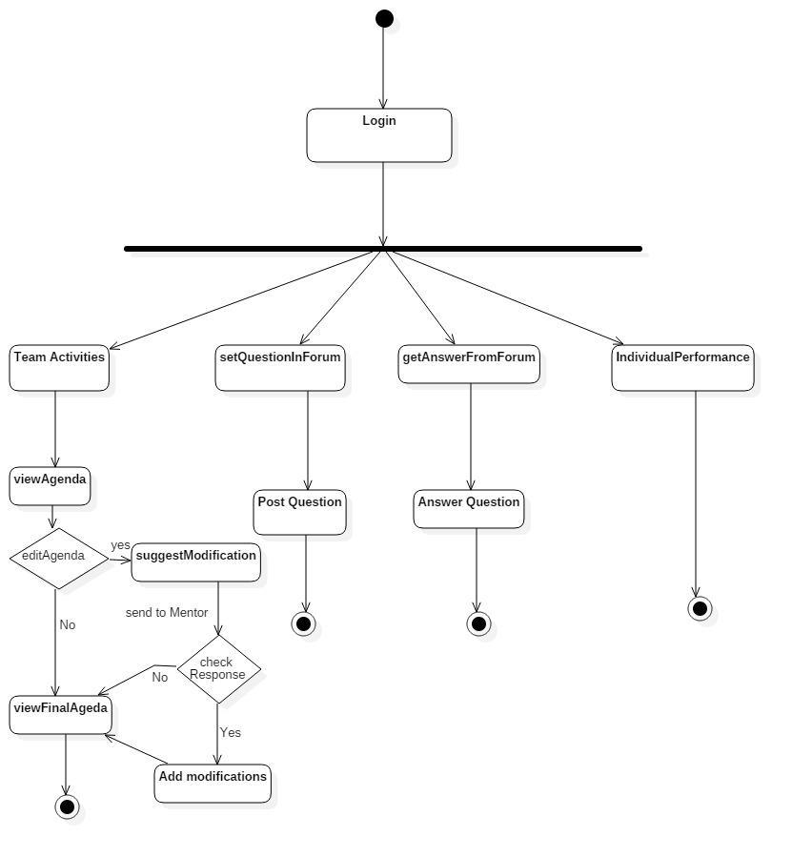

***12***

CDAC Mumbai

DAC Forum & Mentor

Assessment

1. **Sequence Diagram 1.1:**

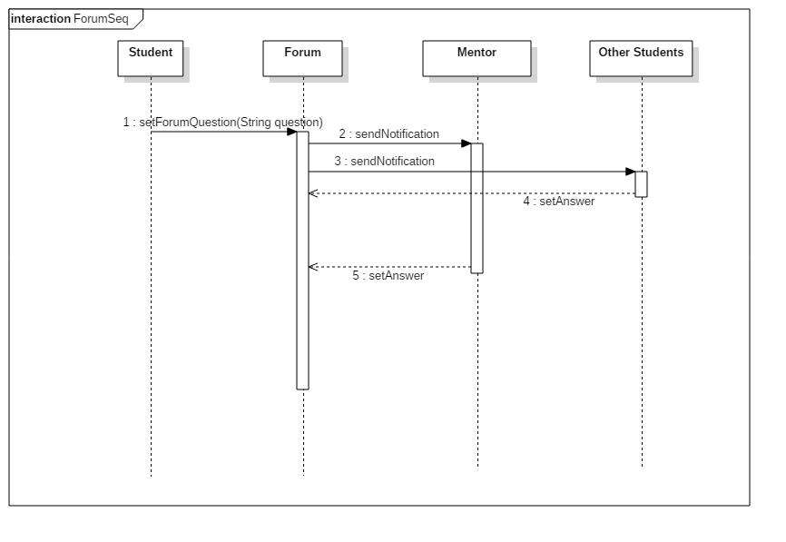

***13***

CDAC Mumbai

DAC Forum & Mentor

Assessment

**Sequence Diagram 1.2:**

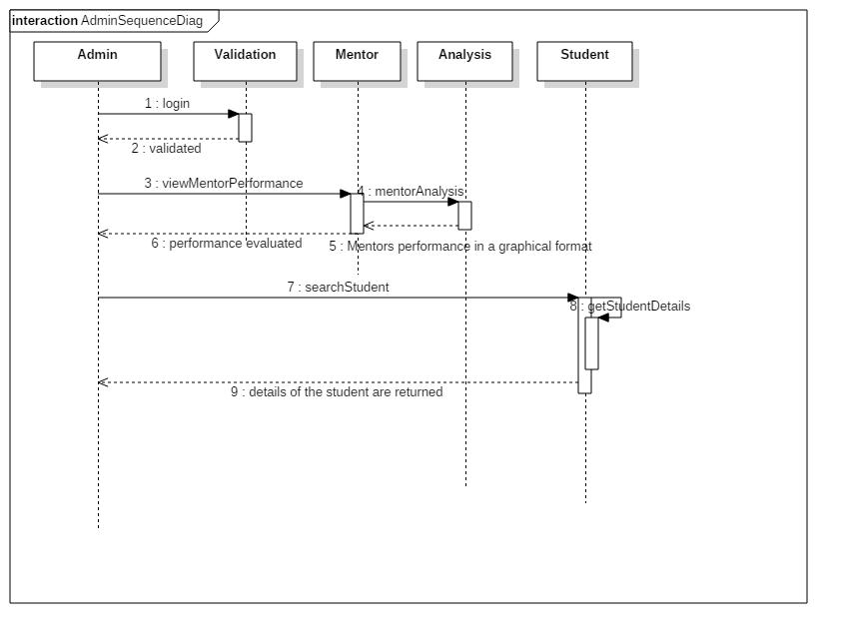

***14***

CDAC Mumbai

DAC Forum & Mentor

Assessment

**Sequence Diagram 1.3:**

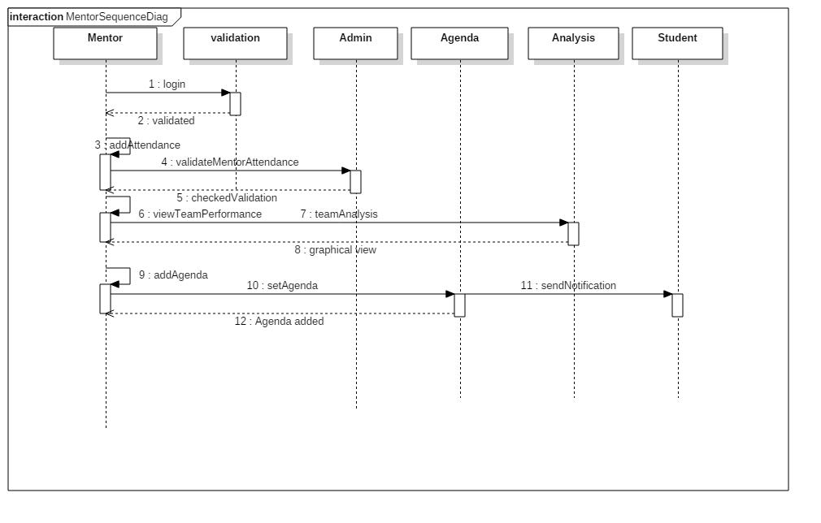

***15***

CDAC Mumbai

DAC Forum & Mentor

Assessment

**Sequence Diagram 1.4:**

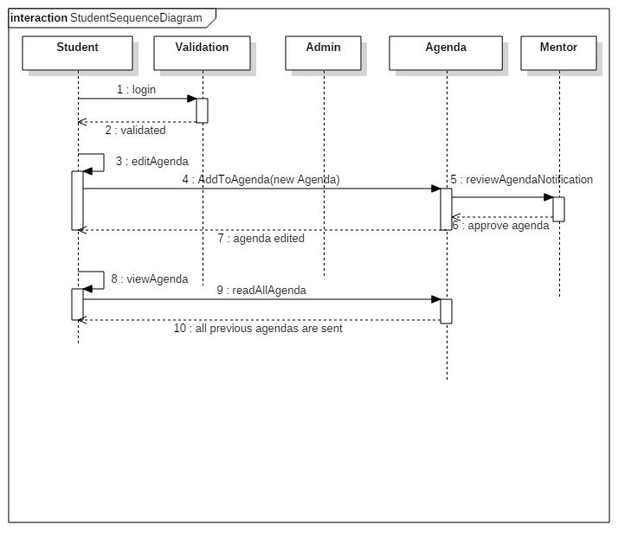

***16***